**Dilemma in the practice of pharmaceutical companies: ethics, regulation and complaints**

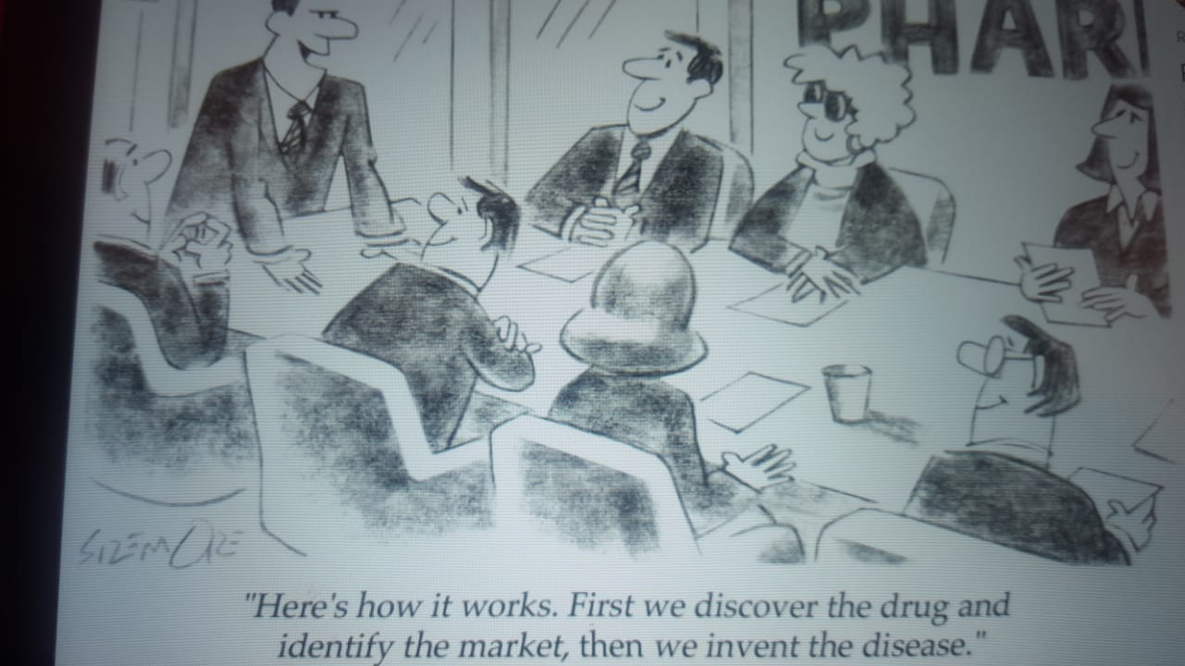

**Ethics**

Business ethics is ethics applied and defined as the critical and structured examination of how people and institutions should behave in the business world.

There are a number of reasons why companies should act ethically: to protect their own interests, to protect the interests of the business community and to build public confidence, to maintain their commitment to society, to meet the expectations of stakeholders, to avoid harming the public, etc.

Different theories of ethics are applied in the pharmaceutical marketing sector;

**Deontology**

Rather than the result of treatment, actions to provide that treatment must be judged.

**Utilitarianism**

Utilitarianism argues that the outcome of people's judgment should be used to judge their actions

**Principles of ethics**

**Principle of autonomy**

Regarding unethical marketing practices, patients are often not given any choice, rather the marketer's influence dictates to them what is bestowed on a particular disease condition. Patients should be afforded a free right to the drugs of their choice when options are available and physicians should not be encouraged to write brand names, rather standard practice of generic drug names should be the rule.

**Principle of beneficence**

This principle is meant to do a good job for everyone. Society as a whole should benefit from the actions of pharmaceutical companies. However, when unethical practices take place, these benefits are denied to society and only a few (shareholders of pharmaceutical companies) benefit from these practices.

**Principle of non-maleficence**

Evidence of misinformation about the effectiveness of a drug that masks its harmful side effects has shown that these practices can lead to unwanted effects and some drug withdrawals later.

**Principe of justice**

When companies invest in drugs that are more profitable than providing drugs that will benefit the most, the principle of fairness is ignored.

**Principle of fidelity**

When the prescriber is influenced by the incentives to describe a particular product, the duty of fidelity is violated.(Khowaja and Feroz, 2020)

Sasirikha cited the unethical practice in the pharmaceutical industry; (Sasirekha, 2018)

1. Evergreening Practices
2. Deployment planning and ghost management
3. Biased industry-funded research
4. Posting bias
5. Mining prescription data
6. Gifts for doctors
7. Industry-Funded CME
8. Promotional Speaking

**Regulation**

The Pharmaceutical Regulations have two simultaneous objectives:

1. Development and production of new and effective therapies for the market

2. Patient protection from unsafe and / or incorrectly branded products.

The WHO Ethical Standards define promotion as "all the informational and persuasive activities of manufacturers and distributors, the effect of which is to induce the prescribing, procurement, purchase and / or use of medicinal drugs."

It was developed as a result of a consensus among health professionals, drug regulatory agencies, consumers and the industry, and thus represents a broader view of appropriate marketing practices than either industry or professional law. The main objective of ethical standards is to support and encourage improvement of healthcare through the rational use of medicines, and they also provide an international ethical standard against which regulatory actions and promotional activities can be compared.

The issues addressed by the WHO ethical standards are:

* The advertisement is for doctors and other health professionals
* Ads of all kinds for the general public
* Medical representatives
* free samples
* Other scientific seminars and meetings
* Post-marketing scientific studies, monitoring and information dissemination
* Packaging and labeling
* Patient information

Some of the key provisions of WHO's ethical standards include the principle that promotion should not be disguised as an educational or scientific activity, that undue advantage should not be taken from people's concern for their health and that DTCA in general for prescription drugs should not be permitted.

Many countries do not adequately regulate pharmaceutical promotion because they lack the necessary resources for pharmaceutical regulation in general.(Ziganshina and Lexchin, 2010)

**Complaints**

The Guardian features various complaints from different pharmaceutical companies.

Pfizer sponsored a campaign for the Impotence Association that carried the company's logo. The UK Prescription Medicines Act Practice Authority - which is part of the Association of the British Medicines Industry (ABPI) - has ruled this is inappropriate because it may encourage patients to ask doctors about Viagra, a Pfizer product, by name.

Eli Lilly, who owns a rival drug, is sponsoring a TV ad campaign in the UK for a website called Love Life Matters, which urges women whose husbands have erectile dysfunction to see a doctor.

In the United States, where advertising is permitted to consumers, a more subtle method has been used. In 2002, Lauren Bacall was interviewed on NBC's Today show, telling an anecdote about a friend who was blinded by macular degeneration and mentioned a new drug for the condition made by Novartis - without revealing that the company had paid her for her appearance. (*Report reveals tricks of pharmaceutical trade | Guardian Weekly | guardian.co.uk*, no date)

Additionally, Guardian investigated allegations of sexual favors and corruption by employees of an international pharmaceutical company in Jordan and Lebanon. (*GlaxoSmithKline says it is investigating bribery claims in Jordan and Lebanon | GlaxoSmithKline | The Guardian*, no date)

In a study published in 2010, Niquette showed the difference between the information sent between a disease Facebook page and a drug Facebook page.

The commercial / medicine page / explains the importance of the medicine and the importance of the role of the responsible mother in purchasing the medicine, while the other page explains all the factors that can reduce the disease for patients without mentioning the importance of mothers.(Niquette, no date)

**Comments and posts on social media**

If we want to get an idea of ​​people's opinions using social media;

* 430,225 people loved Pfizer
* 387 873 people liked this Novartis company
* 352,000 people liked the Gsk

On the other hand

* 16,781,036 people loved this Toyota
* 29,128,403 people liked this Zara
* 80689,437 people liked this McDonald's

People probably know the drug's name better than the drug company name despite the fact that covid19 was an opportunity for drug companies to step up and patients await their innovations.

If we could see followers of some drug brands,

* 9,351 people liked otrivine Arabia
* 747,170 people liked Prospan
* 2,456 people likedd Nasonex Alergy

We notice that the number of followers of the pages of pharmaceutical companies and drug pages is much less than the pages of car, clothing and food brands.

It is therefore mandatory to know the opinions of people from the comments.

Here are some comments on the publications of pharmaceutical companies;

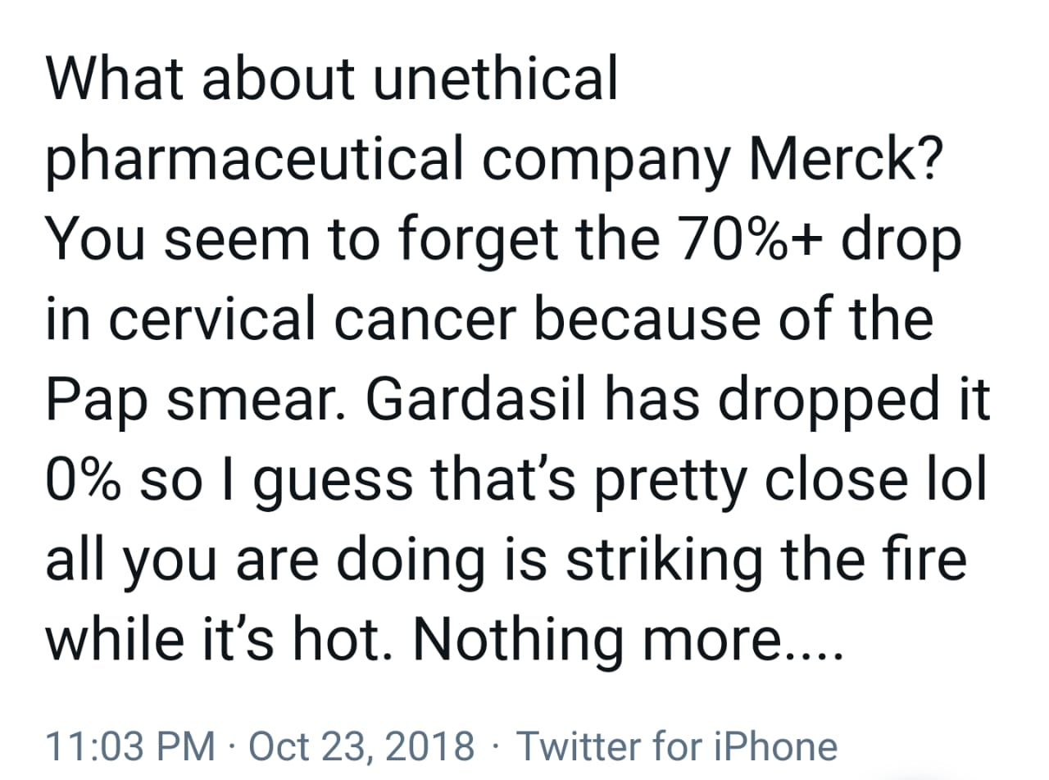

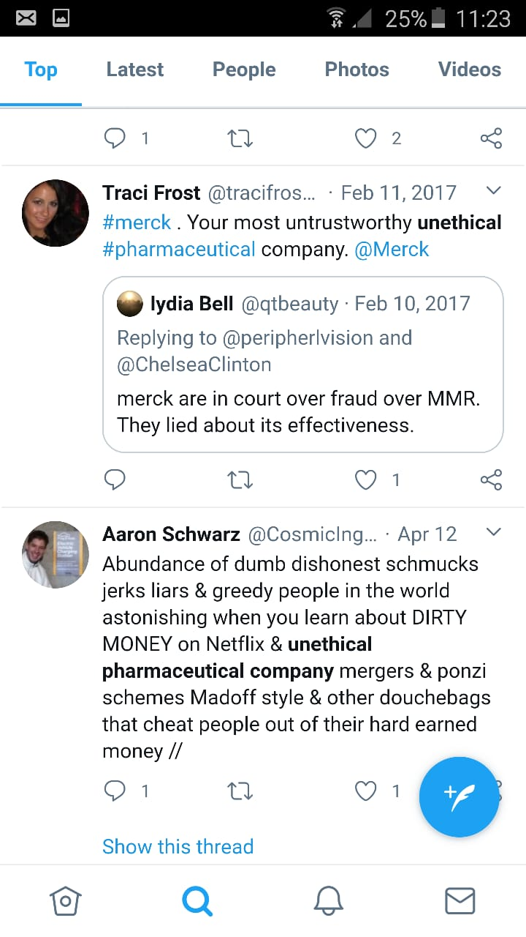

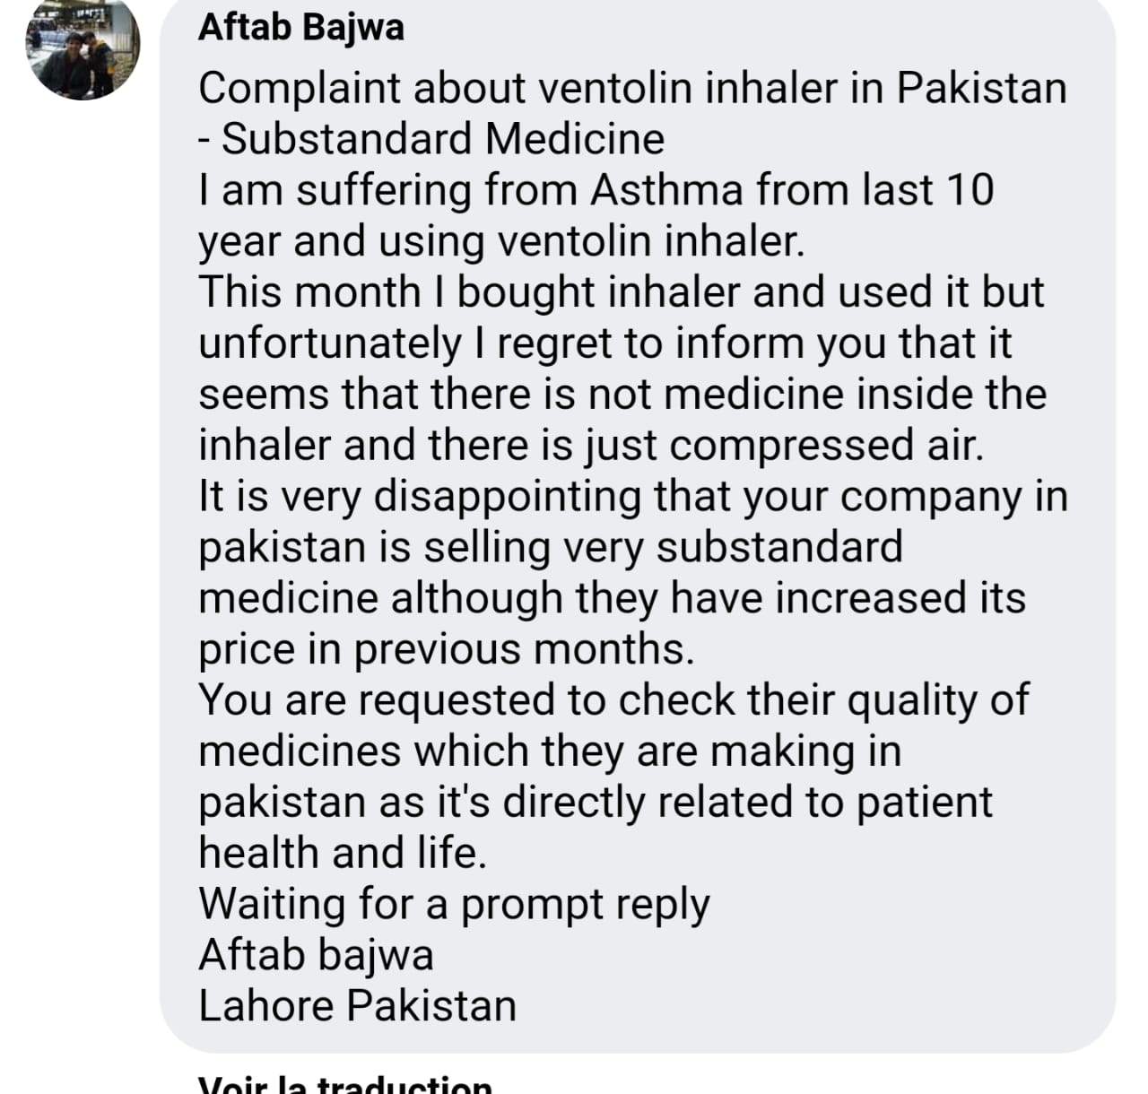

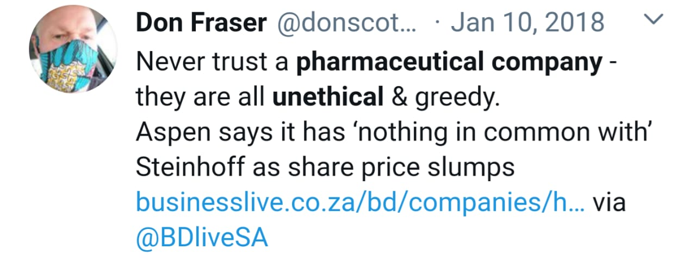

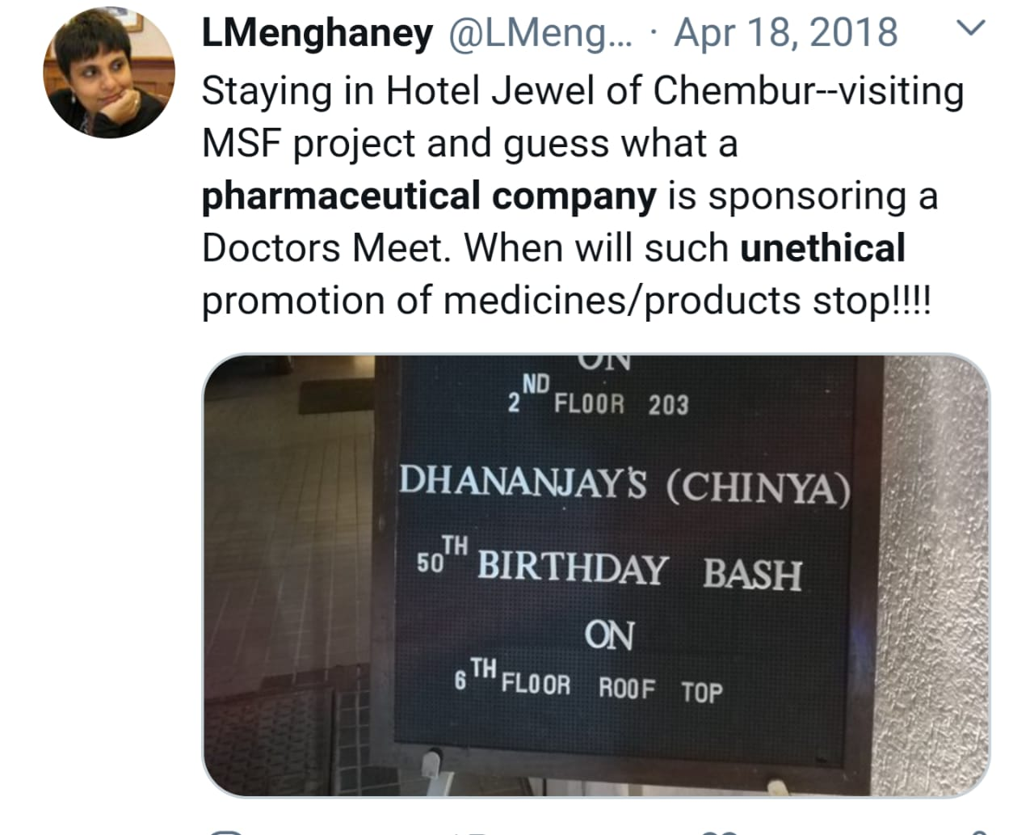

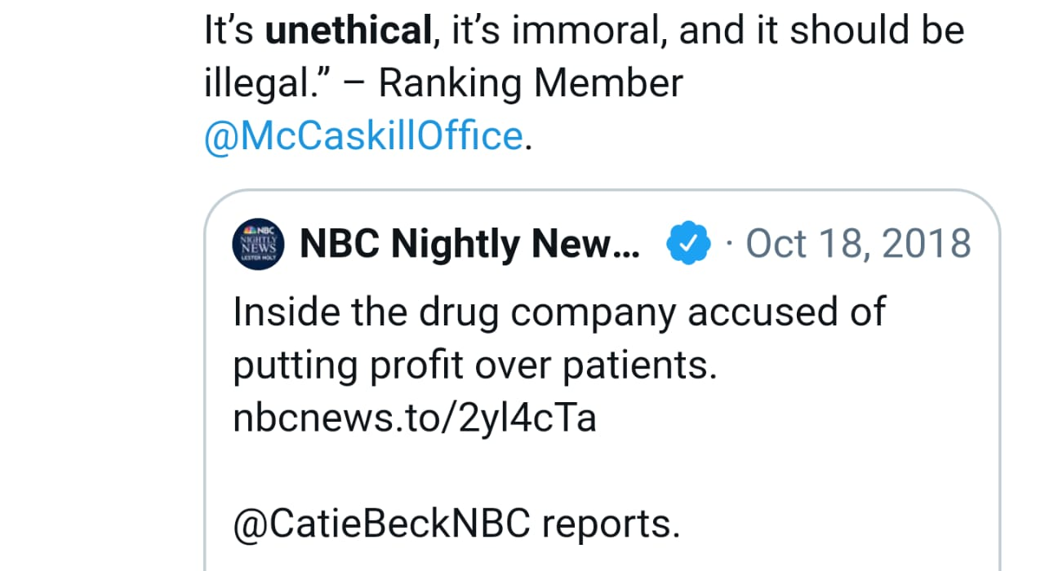

Obviously all drug companies have tried to be very close to patients from their publications. They organize publications to publish in the world day of diabetes, hypertension, cancer ...

“This type of ‘nice-and-friendly’ marketing is often disguised as corporate social responsibility and has been shown to create a subtle need among consumers to demand drugs for the conditions, while giving consumers a sense of trust in the pharmaceutical companies,” says Consumers International.

In other hand, it is typically evident to show this type of posts for medication page on Facebook

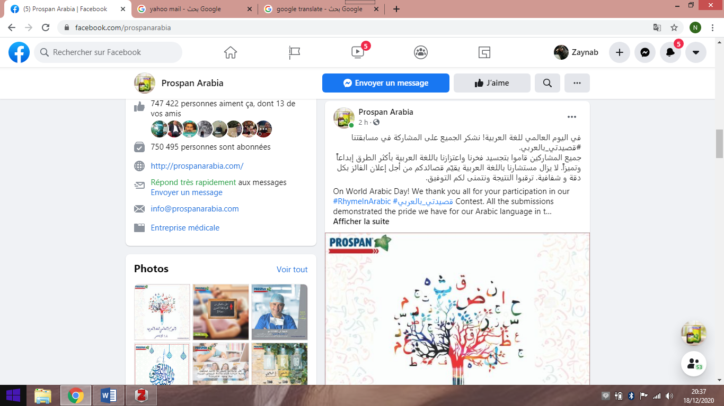

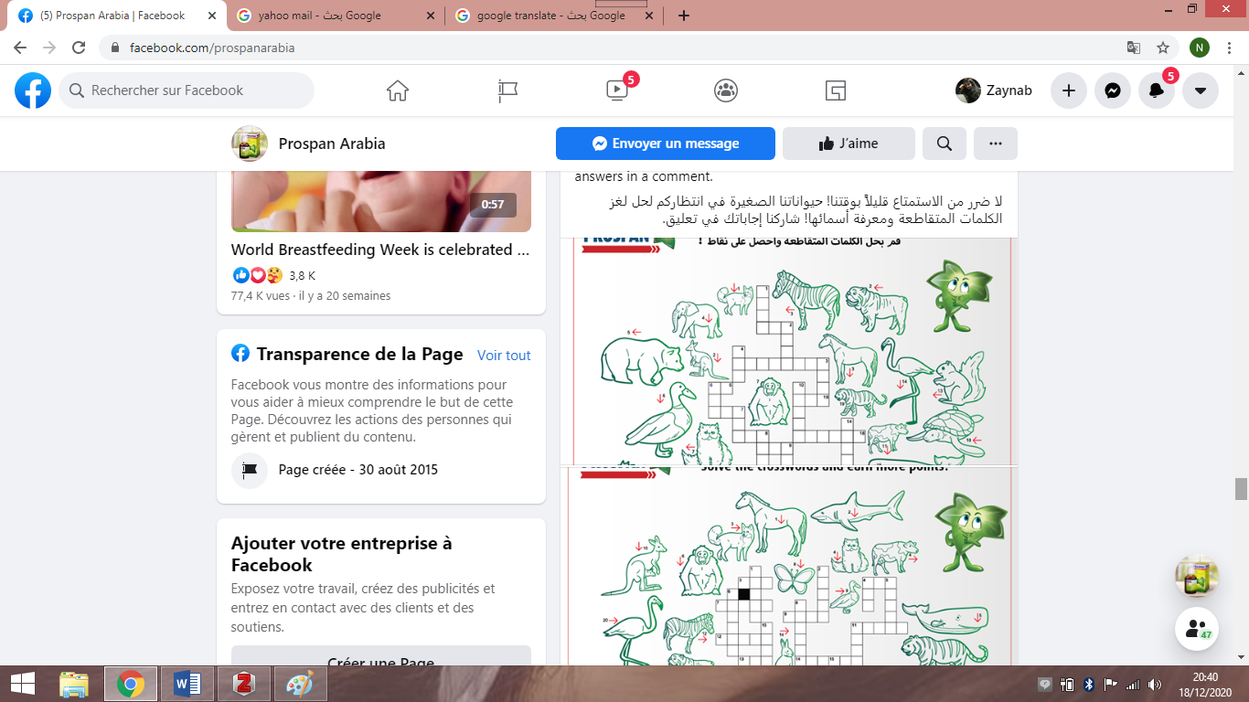

This type of post allows for the creation of a wide connection and thus the sharing of the post which allows spreading the name of Medication thus increasing the purchase.

In addition, the pharmaceutical company tries to implement marketing strategies without respecting medical promotion ethics;

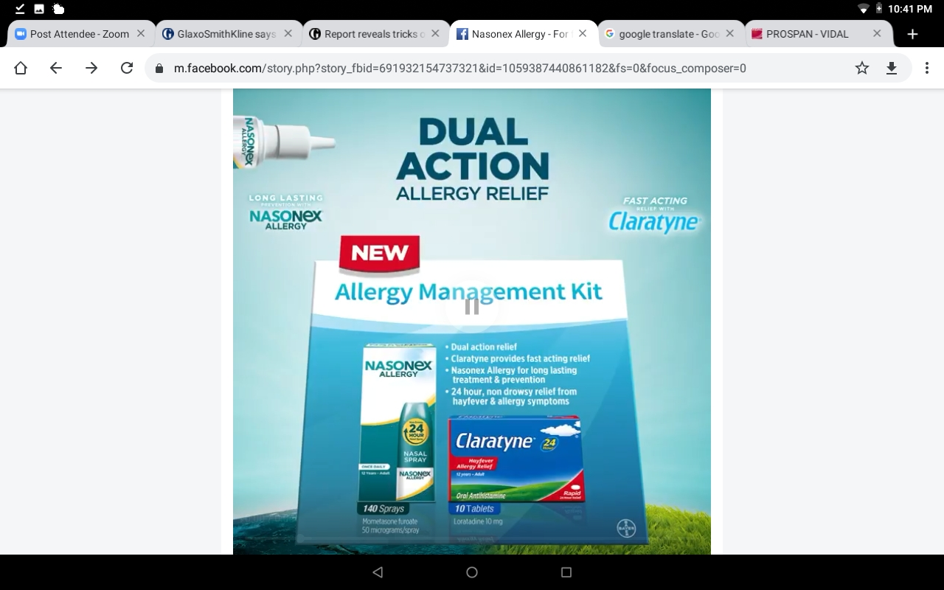

References

*GlaxoSmithKline says it is investigating bribery claims in Jordan and Lebanon | GlaxoSmithKline | The Guardian* (no date). Available at: https://www.theguardian.com/business/2014/apr/16/glaxosmithkline-doctor-bribery-jordan-lebanon (Accessed: 18 December 2020).

Khowaja, R. H. and Feroz, A. (2020) ‘Unethical pharmaceutical marketing in Pakistan: a systematic review’, *Journal of Pharmaceutical Health Services Research*, 11(1), pp. 55–60. doi: 10.1111/jphs.12325.

Niquette, M. (no date) ‘Marketing pharmaceutique et médias sociaux : Analyse critique du discours d’une page FacebookMD sur le TDA/H’, p. 65.

*Report reveals tricks of pharmaceutical trade | Guardian Weekly | guardian.co.uk* (no date). Available at: https://www.theguardian.com/guardianweekly/story/0,,1807960,00.html (Accessed: 18 December 2020).

Sasirekha, V. (2018) ‘ETHICALLY PRACTICED UNETHICAL STRATEGIES IN PHARMA INDUSTRY - WHOM TO BE BLAMED’, *International Journal of Research -GRANTHAALAYAH*, 6(2), pp. 32–45. doi: 10.29121/granthaalayah.v6.i2.2018.1538.

Ziganshina, L. and Lexchin, J. (2010) ‘Regulation of pharmaceutical promotion: Why does regulation matter?’, p. 21.